
1481: Build AI-Powered Staff Schedules with Planning Analytics, CPLEX, and IBM Bob

Hands-on lab guide



Brittany Bogle
Christina Zhao

Brittany.Bogle@ibm.com
Christina.Zhao@ibm.com

Client Engineering
Table of Contents
1 Introduction 4
1.1 About this hands-on lab 4
2 Lab Set Up 4
2.1 Access Lab Files 4
2.2 Setting up Bob 5
3 Lab Instructions! 6
3.1 Understanding your data 7
3.2 Building out your Optimization problem using Bob, watsonx.ai, and IBM CPLEX 7
3.3 Deploying and testing out your solution 8
3.4 Running your Optimization model in Planning Analytics 9
3.4.1 Setup a deployment execution script through Planning Analytics Workbench 9
3.4.2 Create a Book to run the deployment 15
3.4.3 Run the model from the Planning Analytics Book. 22

Notices and disclaimers
© 2026 International Business Machines Corporation. No part of this document may be reproduced or transmitted in any form without written permission from IBM.
U.S. Government Users Restricted Rights — use, duplication or disclosure restricted by GSA ADP Schedule Contract with IBM.
This document is current as of the initial date of publication and may be changed by IBM at any time. Not all offerings are available in every country in which IBM operates.
Information in these presentations (including information relating to products that have not yet been announced by IBM) has been reviewed for accuracy as of the date of initial publication and could include unintentional technical or typographical errors. IBM shall have no responsibility to update this information.
This document is distributed “as is” without any warranty, either express or implied. In no event, shall IBM be liable for any damage arising from the use of this information, including but not limited to, loss of data, business interruption, loss of profit or loss of opportunity. IBM products and services are warranted per the terms and conditions of the agreements under which they are provided. The performance data and client examples cited are presented for illustrative purposes only. Actual performance results may vary depending on specific configurations and operating conditions.
IBM products are manufactured from new parts or new and used parts.
In some cases, a product may not be new and may have been previously installed. Regardless, our warranty terms apply.”
Any statements regarding IBM's future direction, intent or product plans are subject to change or withdrawal without notice.
Performance data contained herein was generally obtained in a controlled, isolated environments. Customer examples are presented as illustrations of how those customers have used IBM products and the results they may have achieved. Actual performance, cost, savings or other results in other operating environments may vary.
References in this document to IBM products, programs, or services does not imply that IBM intends to make such products, programs or services available in all countries in which IBM operates or does business.
Workshops, sessions and associated materials may have been prepared by independent session speakers, and do not necessarily reflect the views of IBM. All materials and discussions are provided for informational purposes only, and are neither intended to, nor shall constitute legal or other guidance or advice to any individual participant or their specific situation.
It is the customer’s responsibility to ensure its own compliance with legal requirements and to obtain advice of competent legal counsel as to the identification and interpretation of any relevant laws and regulatory requirements that may affect the customer’s business and any actions the customer may need to take to comply with such laws. IBM does not provide legal advice or represent or warrant that its services or products will ensure that the customer follows any law.

Notices and disclaimers (Continued)
Questions on the capabilities of non-IBM products should be addressed to the suppliers of those products. IBM does not warrant the quality of any third-party products, or the ability of any such third-party products to interoperate with IBM’s products. IBM expressly disclaims all warranties, expressed or implied, including but not limited to, the implied warranties of merchantability and fitness for a purpose.
The provision of the information contained herein is not intended to, and does not, grant any right or license under any IBM patents, copyrights, trademarks or other intellectual property right.
IBM, the IBM logo, and ibm.com are trademarks of International Business Machines Corporation, registered in many jurisdictions worldwide. Other product and service names might be trademarks of IBM or other companies. A current list of IBM trademarks is available on the Web at “Copyright and trademark information” at: www.ibm.com/legal/copytrade.shtml.

Introduction
This lab brings together three IBM technologies to solve a workforce planning problem.
IBM Planning Analytics is an AI-powered planning platform that serves as the data backbone of this lab. It stores all workforce data — employee attributes, budget parameters, shift costs, and new hire information — and provides the environment where planners already work. Results are written back directly to PA, so the optimal staffing plan is immediately visible and explorable in the same tool the business uses every day.
IBM CPLEX is the mathematical optimization engine that powers the core of this lab. Given a $1.65M budget cap and a hospital unit staffing problem: which new hires to bring on, which shift to assign each clinician, and what merit raise to award. CPLEX quickly evaluates all trade-offs and finds the optimal plan.
IBM Bob is an AI coding assistant that makes the entire workflow accessible. Participants will use Bob to build the CPLEX optimization model, write the PA data connectors, and package the solution for deployment — guided by natural language prompts, with no prior knowledge of mathematical programming required. Bob helps turn a complex end-to-end optimization project into something any practitioner can build in a single lab session.

About this hands-on lab

The main objective of this hands-on lab is to show how IBM Planning Analytics, IBM CPLEX, and Bob can work together to solve a workforce planning problem without requiring deep expertise in optimization.
Oftentimes, planners have the data and the business question but lack the skills to translate one into the other. This lab helps show how that gap can be bridged. Participants take on the role of a hospital unit budget manager who must simultaneously decide which new hire slots to activate, which shift band to assign each clinician, and what merit raise to award — all within a hard $1.65M annual budget cap. No spreadsheet can navigate these trade-offs effectively.

The lab runs end-to-end in three stages. Lab participants will read live data directly from Planning Analytics cubes, then use Bob to build, solve, and deploy the CPLEX optimization model through guided prompts with no prior knowledge of mathematical programming required. Then in Planning Analytics, they will learn how to set up and run the deployment, then visualize the optimized output in Planning analytics itself.

Lab Set Up
This lab set up is assuming that you have been able to log into IBM Cloud, Planning Analytics, and that Bob is accessible on the machine that you are running the lab on.

Access Lab Files
- Files are here in this Box folder. Use the password ibmlab1481 to enter. Download the txc-bob-pa-do zip file in the folder clicking the checkmark next to the file, then the download button to the top right of the page.
- Open the zip file.

Setting up Bob
- Open up your Bob window. In the top left corner, select the file icon, and then select “Open Folder”. Select the folder that you downloaded. Bob will now be able to access the files within the folder and work on them.
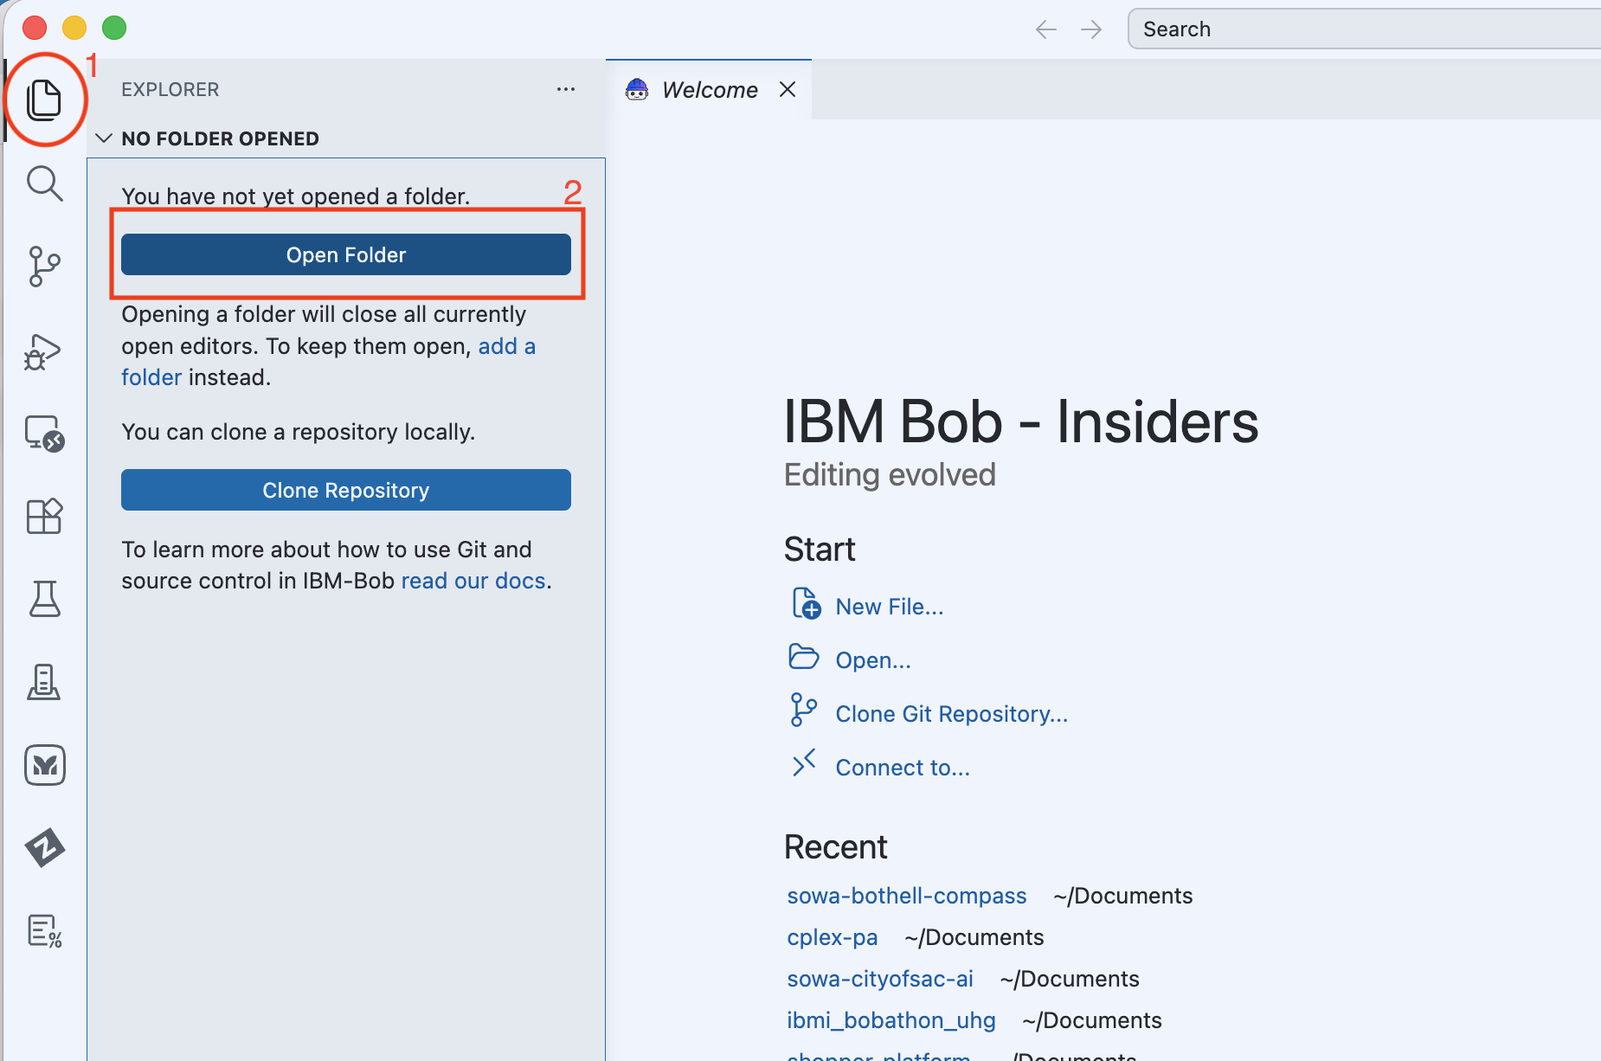
**NOTE: sometimes when you open a folder in Bob, it starts out as “restrctived mode”. There will usually be a popup that asks if you want to trust the folder. You will select “manage” and then trust. This will allow Bob to look at the contents of the folder.
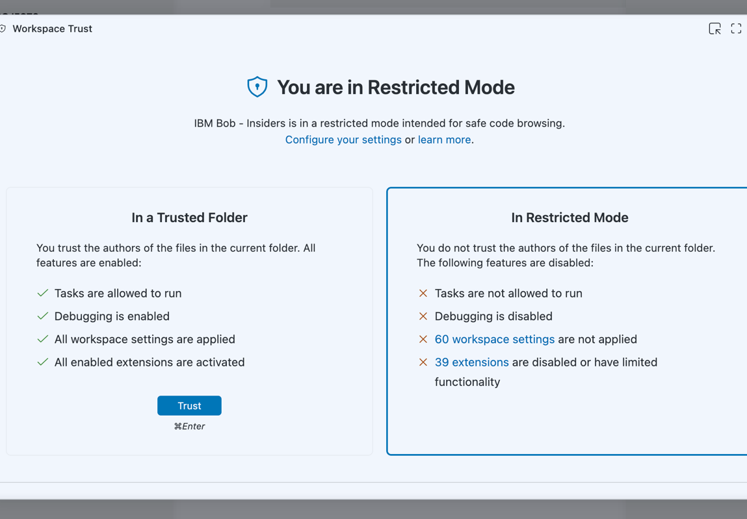
- Now, go to the top and click “Terminal”, then select “New Terminal”. A terminal will pop up on the bottom.
- Now, right click on “SETUP.md” and select “Open Preview”.
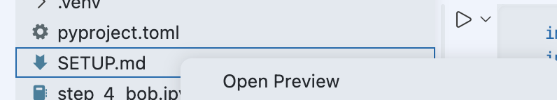
- Follow the instructions in the file to create and activate your python virtual environment that you will be using throughout this lab.

Lab Instructions!

Understanding your data
- In Bob, where you have imported your folder, go ahead and open the notebook named “step_123_bob.ipynb”.
- The credentials for connecting to Planning Analytics and watsonx.ai will already be populated in the notebook.
- In the corner of the notebook, select a Kernel. This Kernel will be the python virtual environment you created above.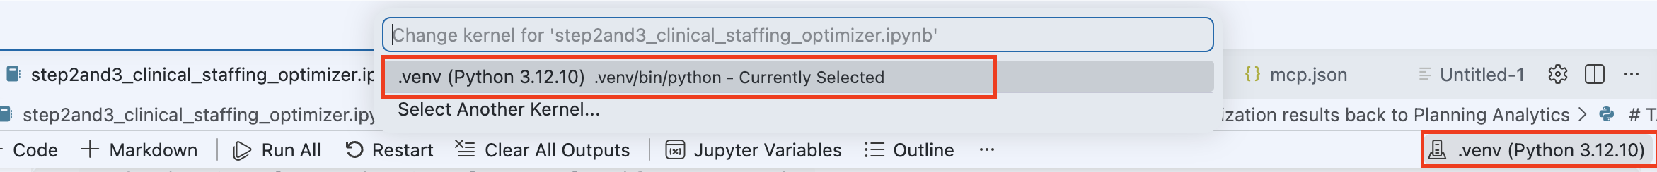
- Fill in the credentials, and then run through the first few cells in the notebook by pressing the play button next to each cell. By running through this notebook, you will ensure that the connections with the credentials work, and explore the data that lives within the Planning Analytics database.

Building out your Optimization problem using Bob, watsonx.ai, and IBM CPLEX
- Once you’ve finished running the first 3 cells in the notebook, you can begin working with Bob to build out a staffing and budget optimization problem. The Bob prompts you will follow live here.
Using the prompts, Bob will write out code that:
a. Loads data from planning analytics.
b. Test the feasibility of your business problem.
b. Determine what will be your constraints and constants in the problem.
c. Write a baseline heuristic that you can use to compare against the optimization solve.
- In the notebook, you’ll need to set the TARGET_VERSION. (this is in the very first cell of the notebook) This is a specific target space where your optimization results will be stored. This should be your firstnamelastname. (for example- ‘target_version’: ‘christinazhao’)
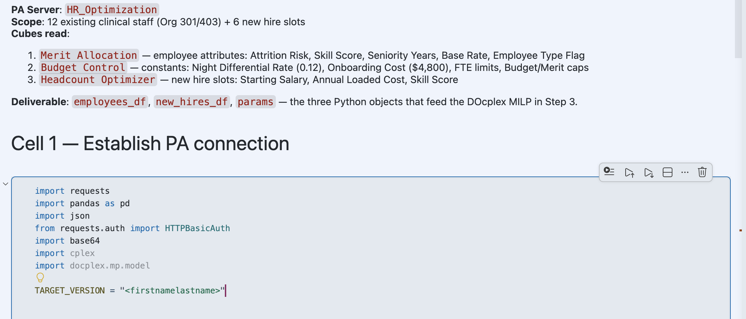
- Run through the Bob prompts and fill in the cells.
Bob will give you the code, but not edit your notebook. Each time you get code output from Bob, make a new ‘code’ cell in the notebook by either:
  - Hovering under the output of the latest cell you’ve run and selecting the “+ Code” button.
  - There’s a “+ Code” button on the top left of the notebook as well.
Then you will paste the code and run the cell by either clicking the play button next to the cell.

Deploying and testing out your solution
- Go back to your Bob window. Open up the notebook named “step4_bob.ipynb”.
- In the notebook, like the last, you’ll need to set the TARGET_VERSION. This is a specific target space where your optimization results will be stored. This should be your firstnamelastname. (for example- ‘target_version’: ‘christinazhao’)
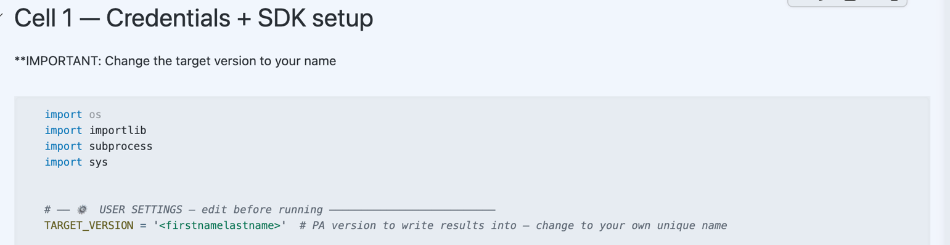
- Similar to the first notebook, the Bob prompts you will follow live here to help you build out the deployment of the DO solution you created and tested out in the first notebook.
- Follow the prompts and fill in the code blocks, then run through the cells to successfully deploy your solution to the watsonx.ai deployment space, run a test job to ensure that the deployment works and check that your optimized data is written back to Planning Analytics.

Running your Optimization model in Planning Analytics

Setup a deployment execution script through Planning Analytics Workbench

3.4.1.1 Create a new workbench
- From Planning Analytics Home Page click the hamburger menu, then click New and then Workbench
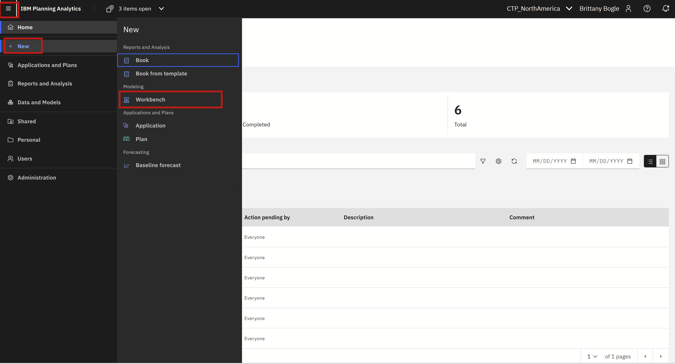
- Save your new workbench by clicking the Save icon, then clicking Save Workbench As
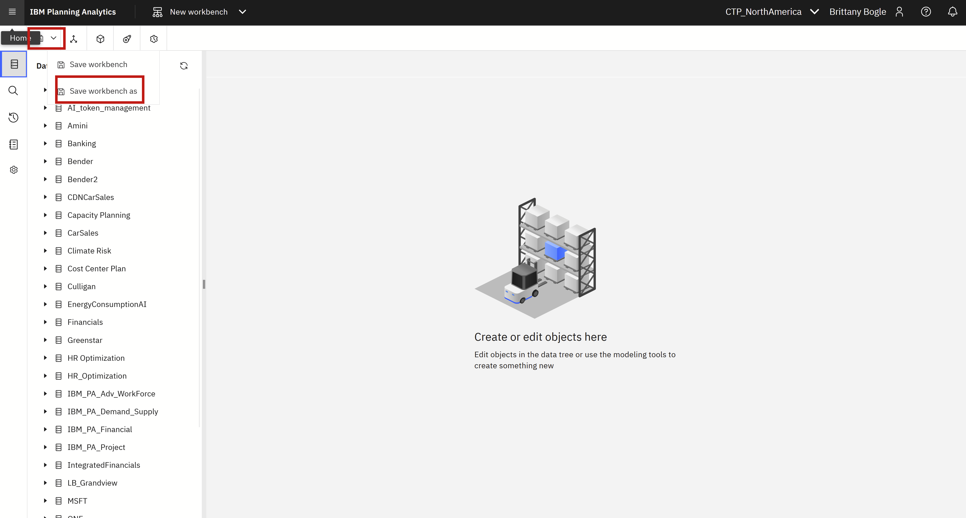

Then in the Save Workbench window, find the Shared tab and find and click into the HR_Optimization shared folder.
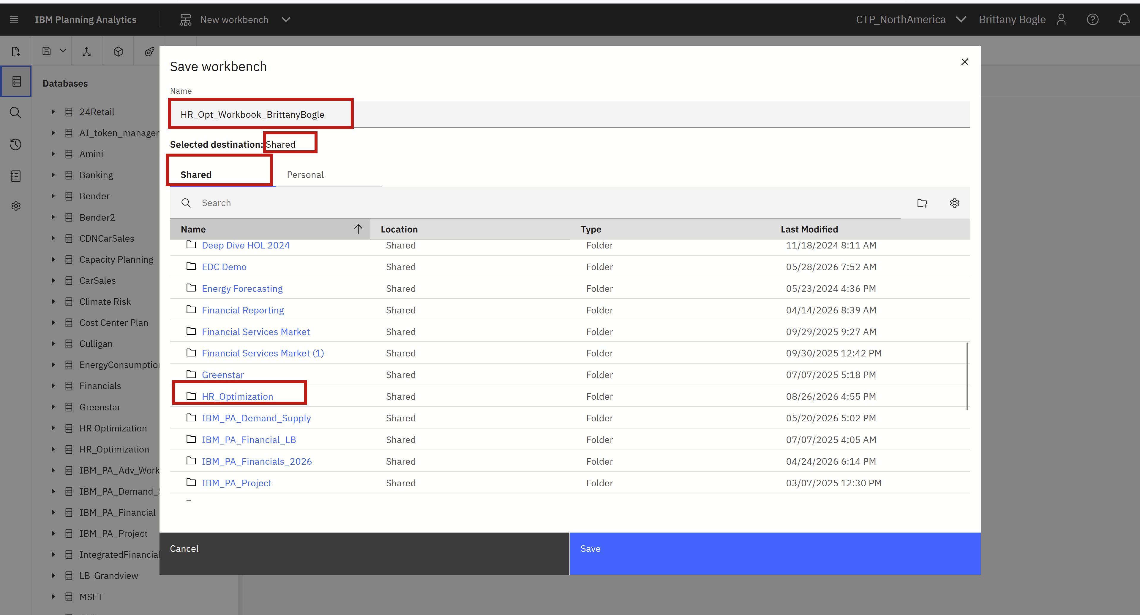
Then in the Name box name your workbench HR_Opt_Workbench_[YourFirstNameYourLastName]
Click Save
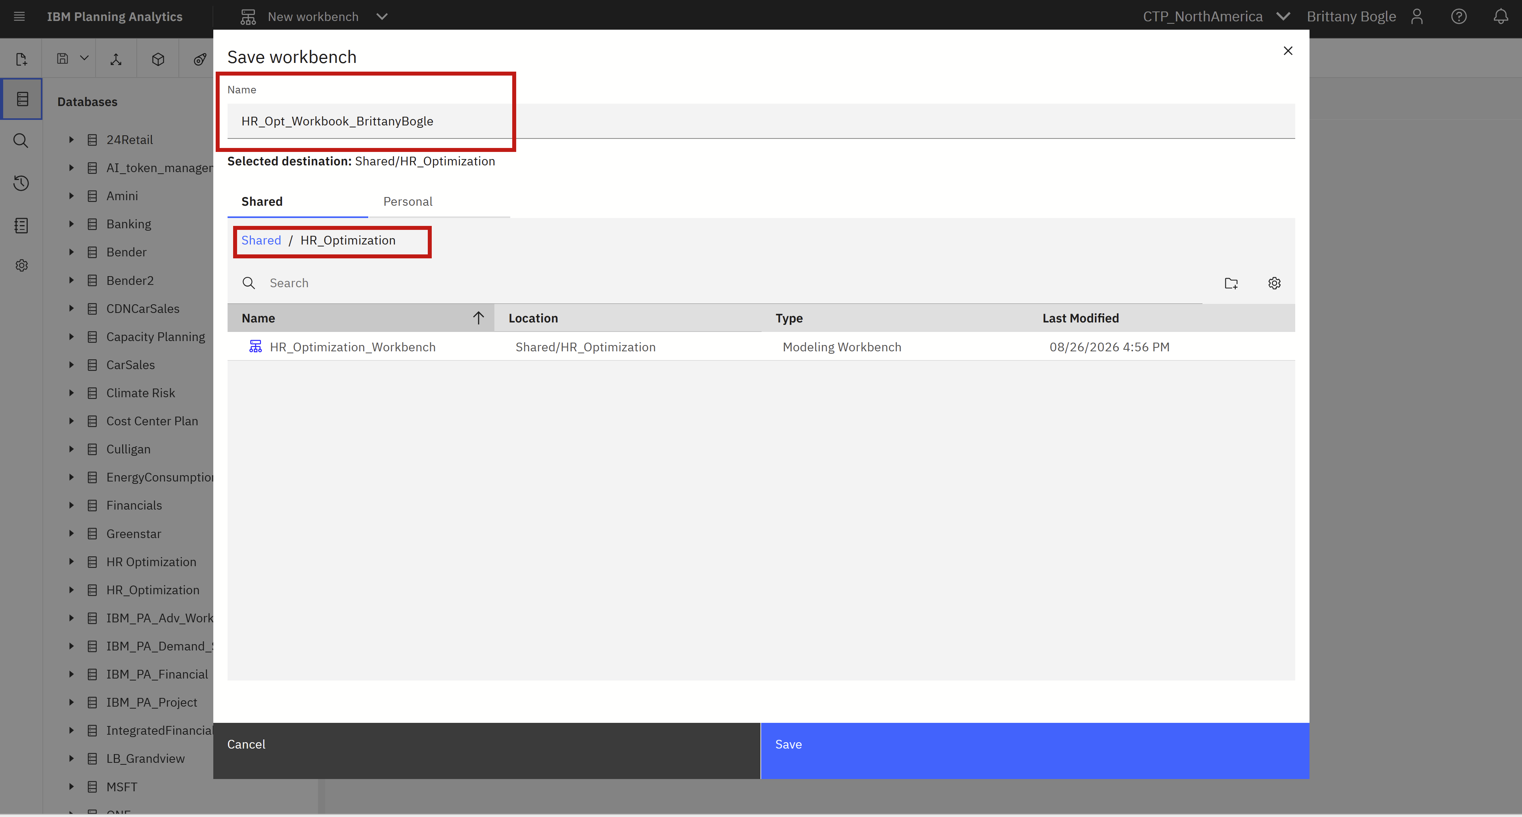

Create new Process in your Workbench
- Click New Process Button
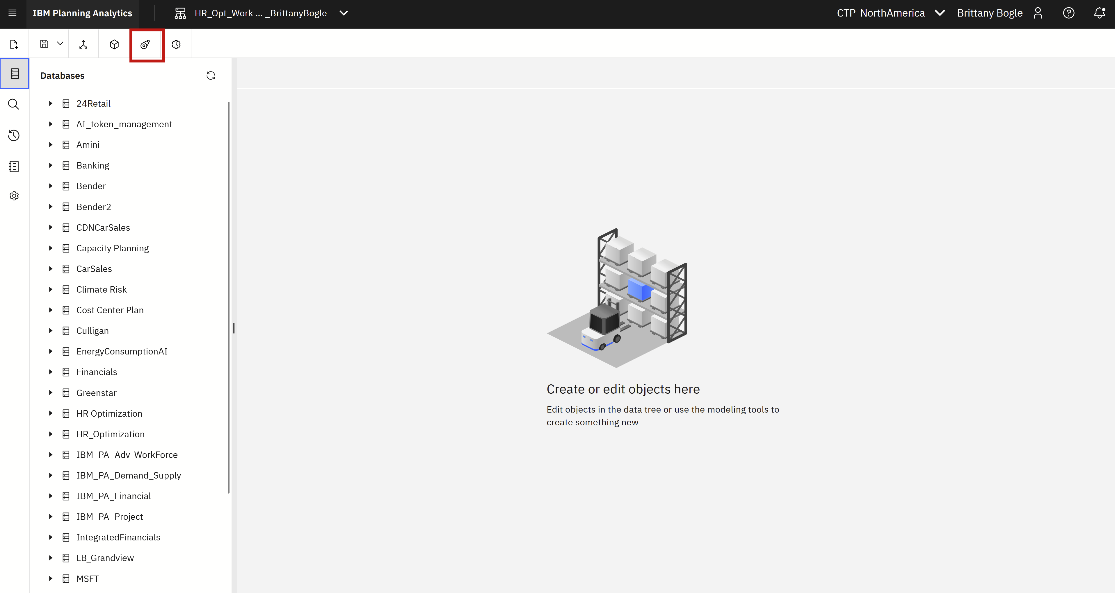
- Under Database find and select HR_Optimization
Give Process Name as HR_Optimization_Process_[YourFirstNameYourLastName]
Click Create
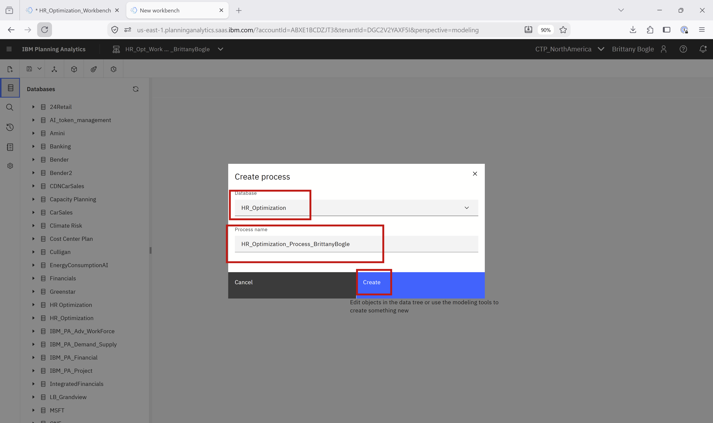

Create Deployment Execution Script in your Workbench Process
- Click the Script tab in the new Process
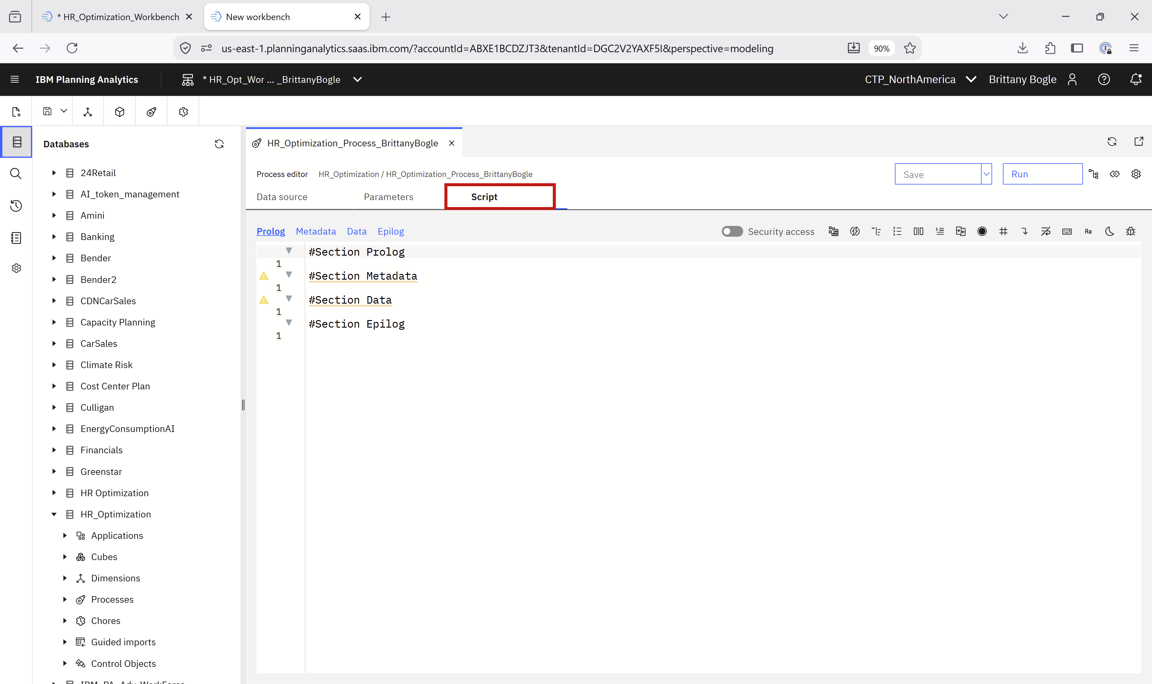

- Open this link to the script file and copy the contents of the file and paste under the #Section Prolog in the Script Tab
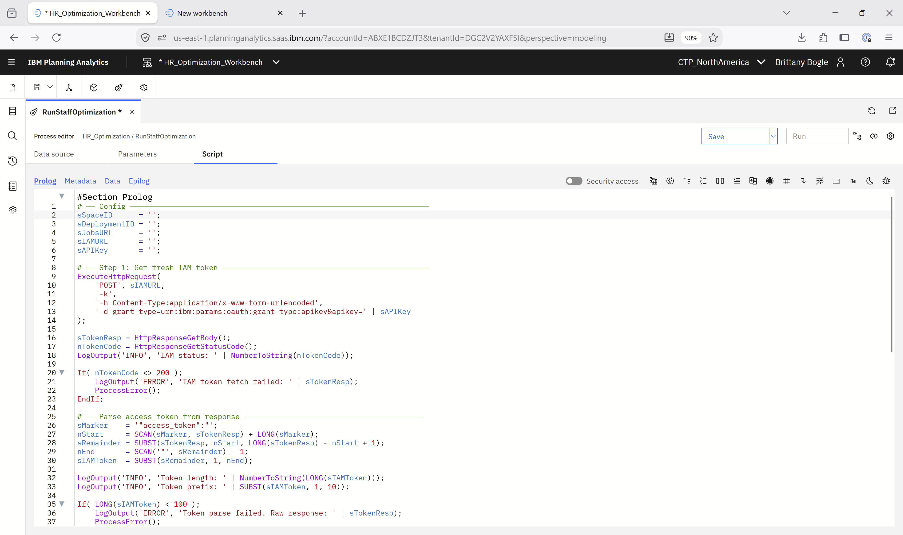
- Open this link to get the credentials and copy the following credentials to replace the empty strings in the top of the script file
sSpaceID = '';
sDeploymentID = '';
sJobsURL = '';
sIAMURL = '';
sAPIKey = '';

- Save the script by clicking Save Icon then Save as
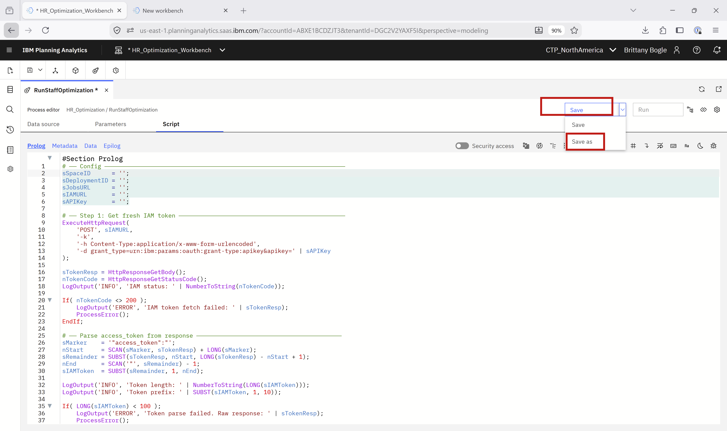

- For Process Name save as RunStaffOptimization_[YourFirstNameYourLastName]
Then click Save As

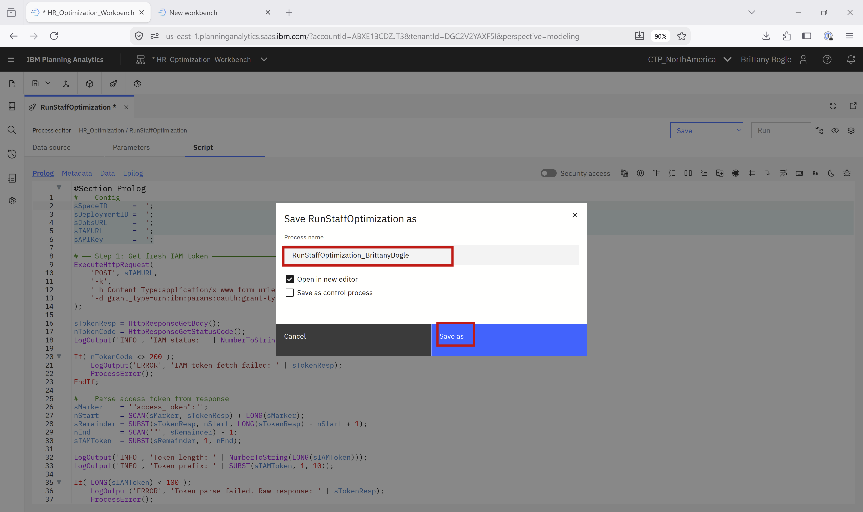
- Select Parameters tab and add one parameter:
Parameter name: pVersion
Type: String
Value: YourFirstNameYourLastName
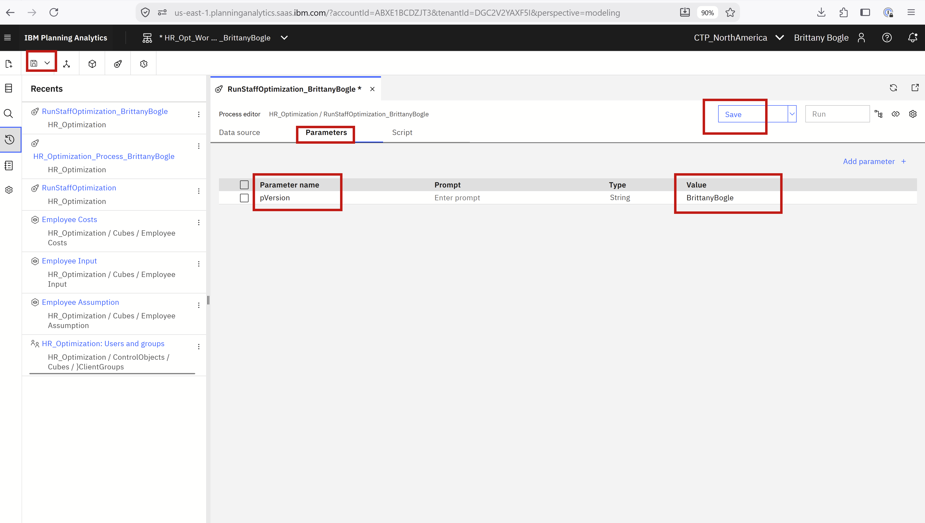

Test Deployment Script
- Click Run
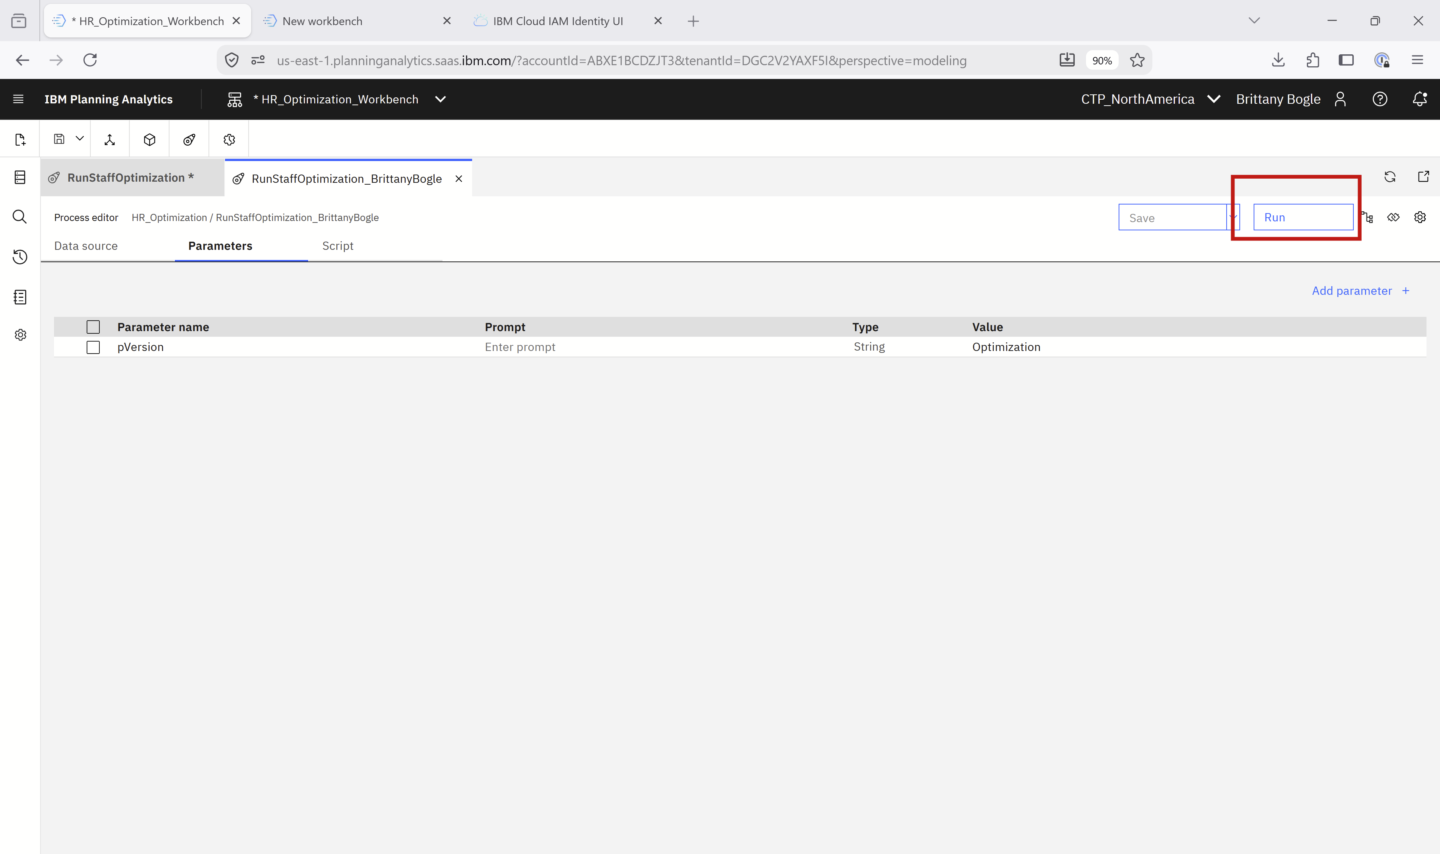
- Then click Run in the popup window

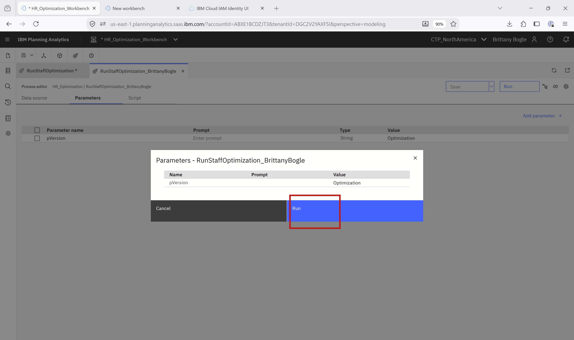

Create a Book to run the deployment
- Click the hamburger menu, then New, then Book.
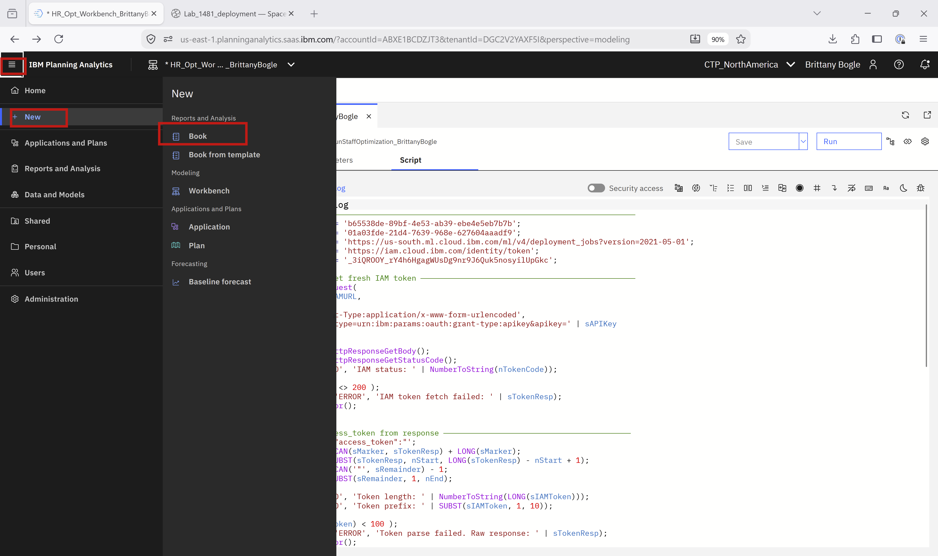
- Click the Save icon, then click Shared tab, then select HR_Optimization folder.
Then in Name field type HR_Opt_Book_[FirstNameLastName]

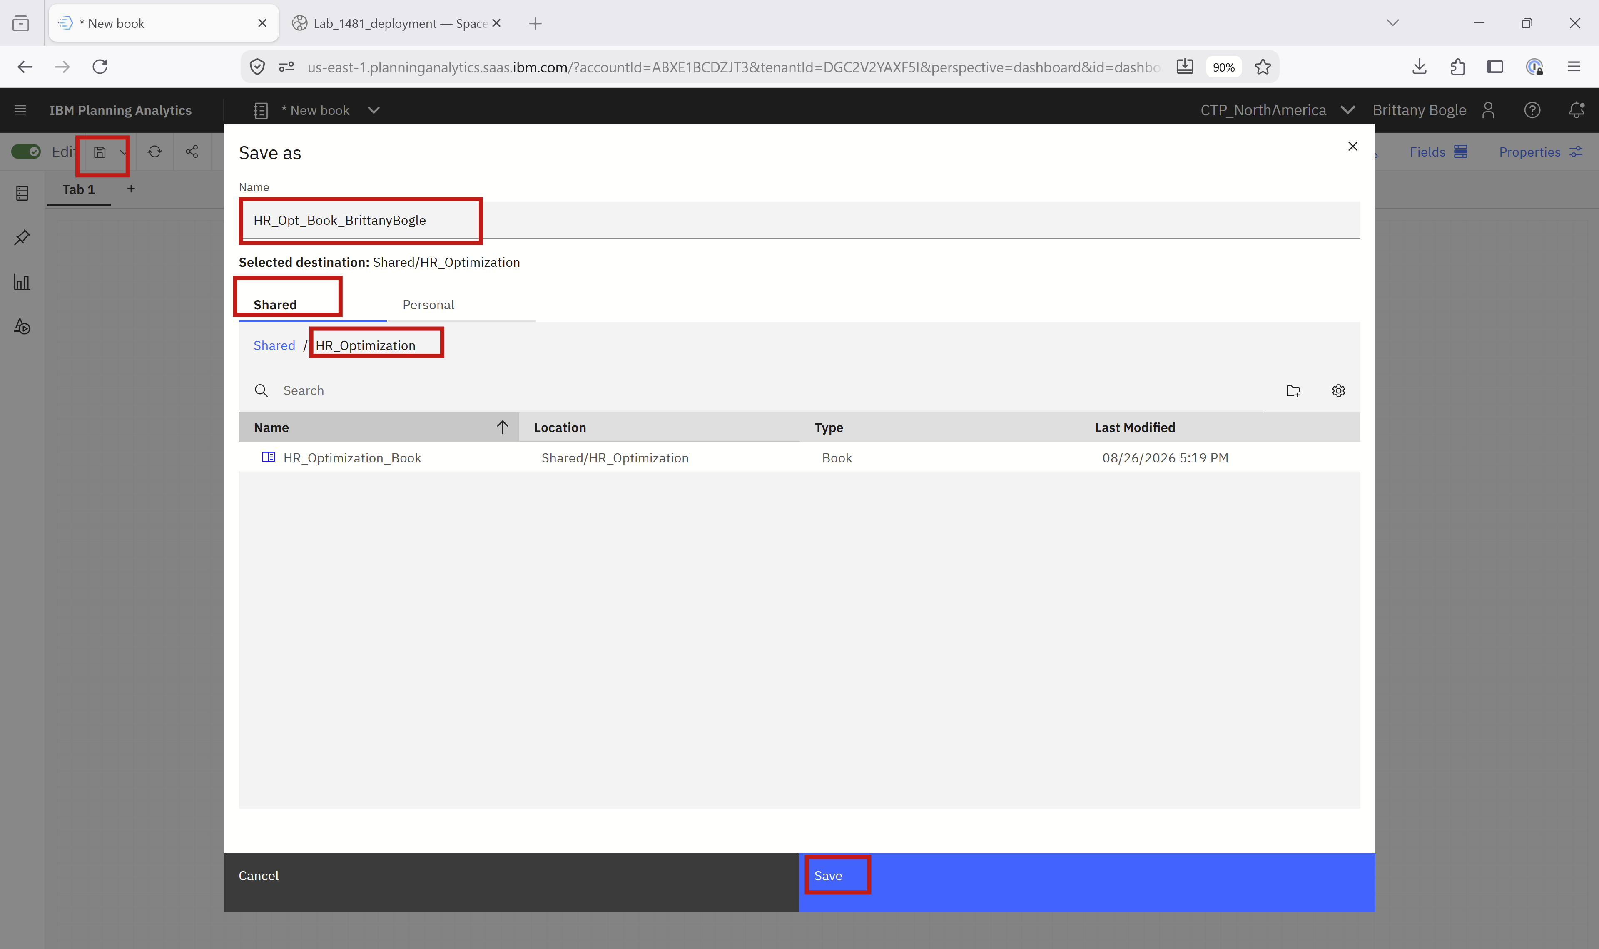
- Click the Widgets button on the left panel, then click the Action Button 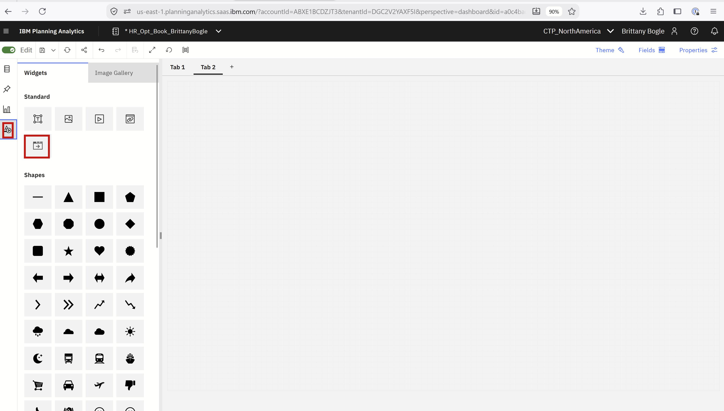
- In the newly created button in the Book, change the title by clicking the text in the button. Change to Run Optimization Model

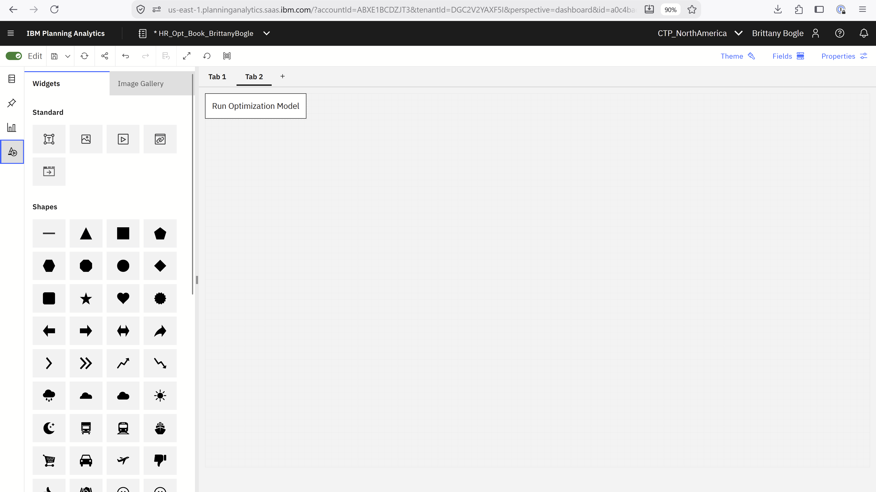
- Click the button again, and then click Properties (right upper corner), then the Configure tab, then select ON(green toggle) the Run Process.
Then, select:
Database: HR_optimization
Processes: HR_Optimization_[YourFirstNameYourLastName]
Check the box: Refresh after execution
Then in the left side of your screen, click the Save icon and click Save.
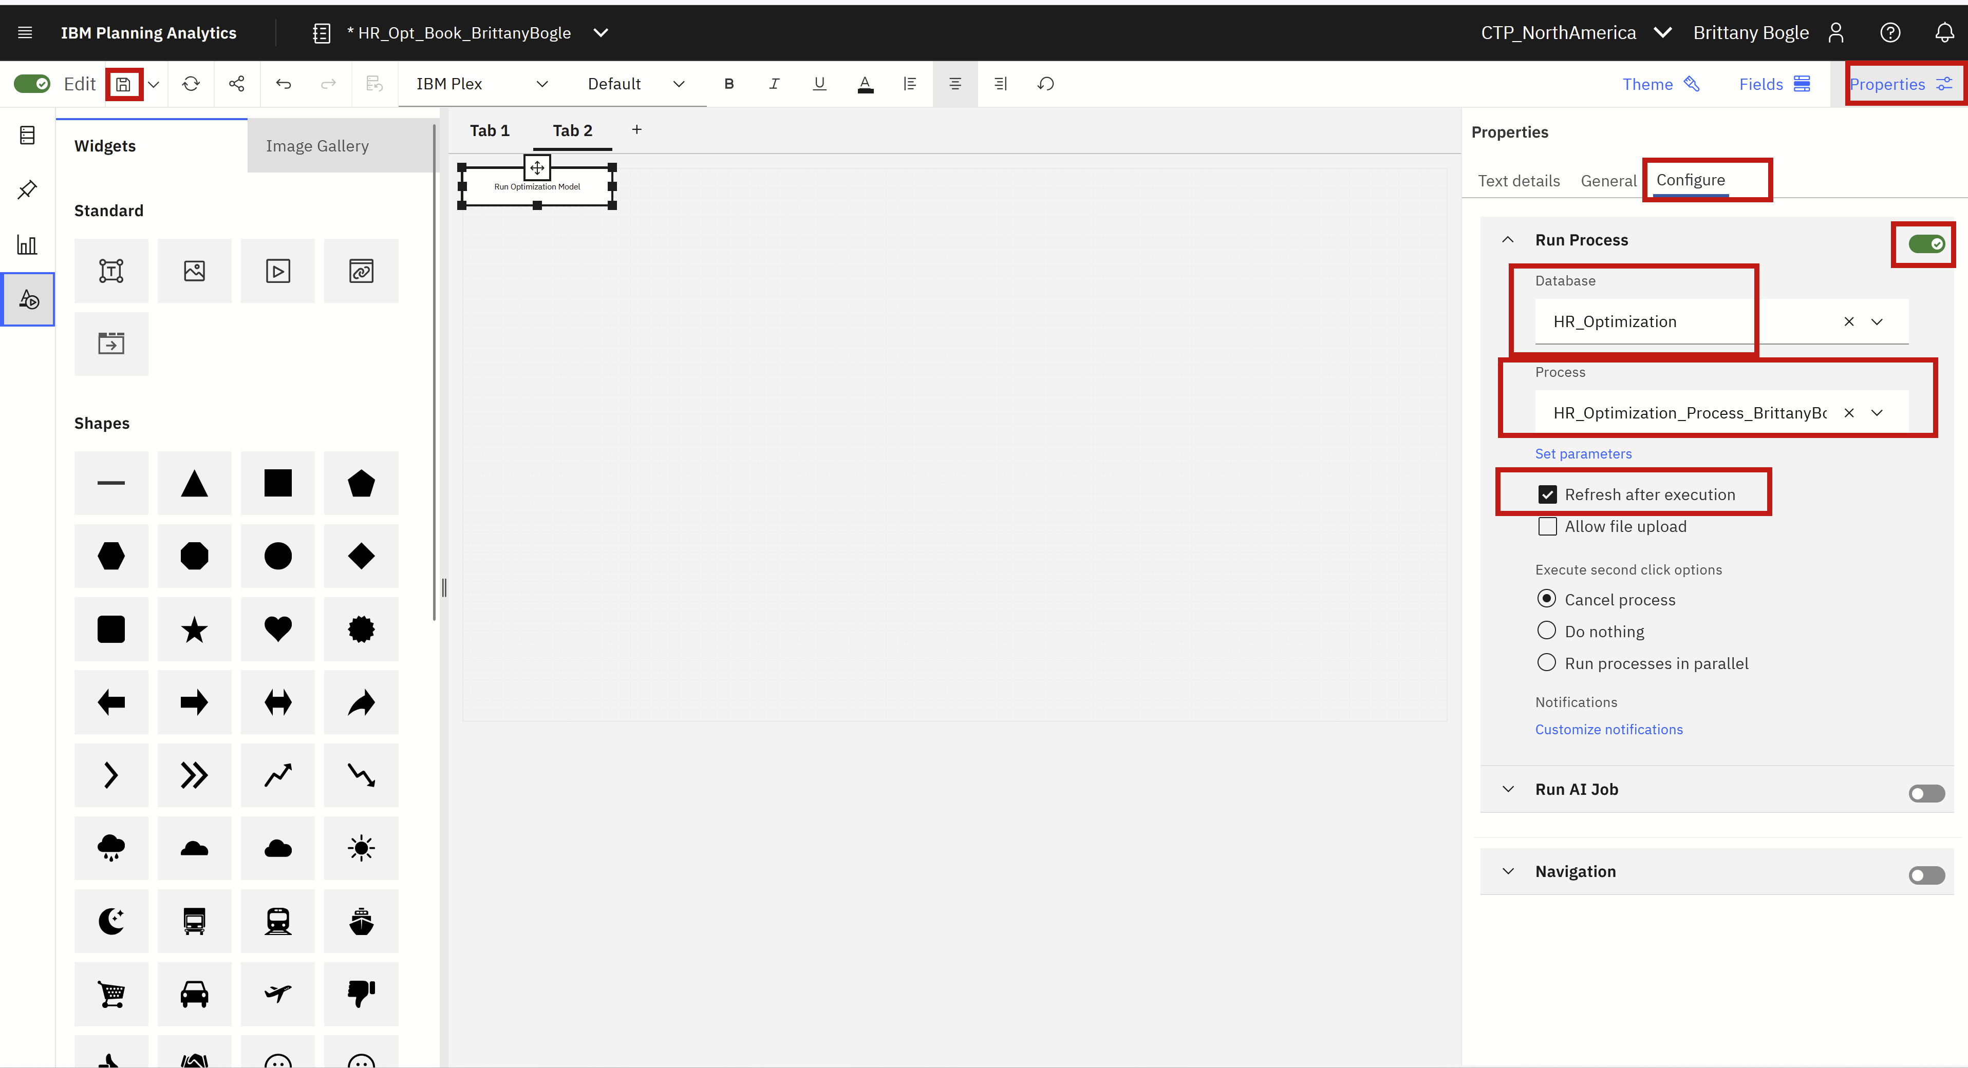
- Click the Widgets logo on left side panel, then click Explorations tile.
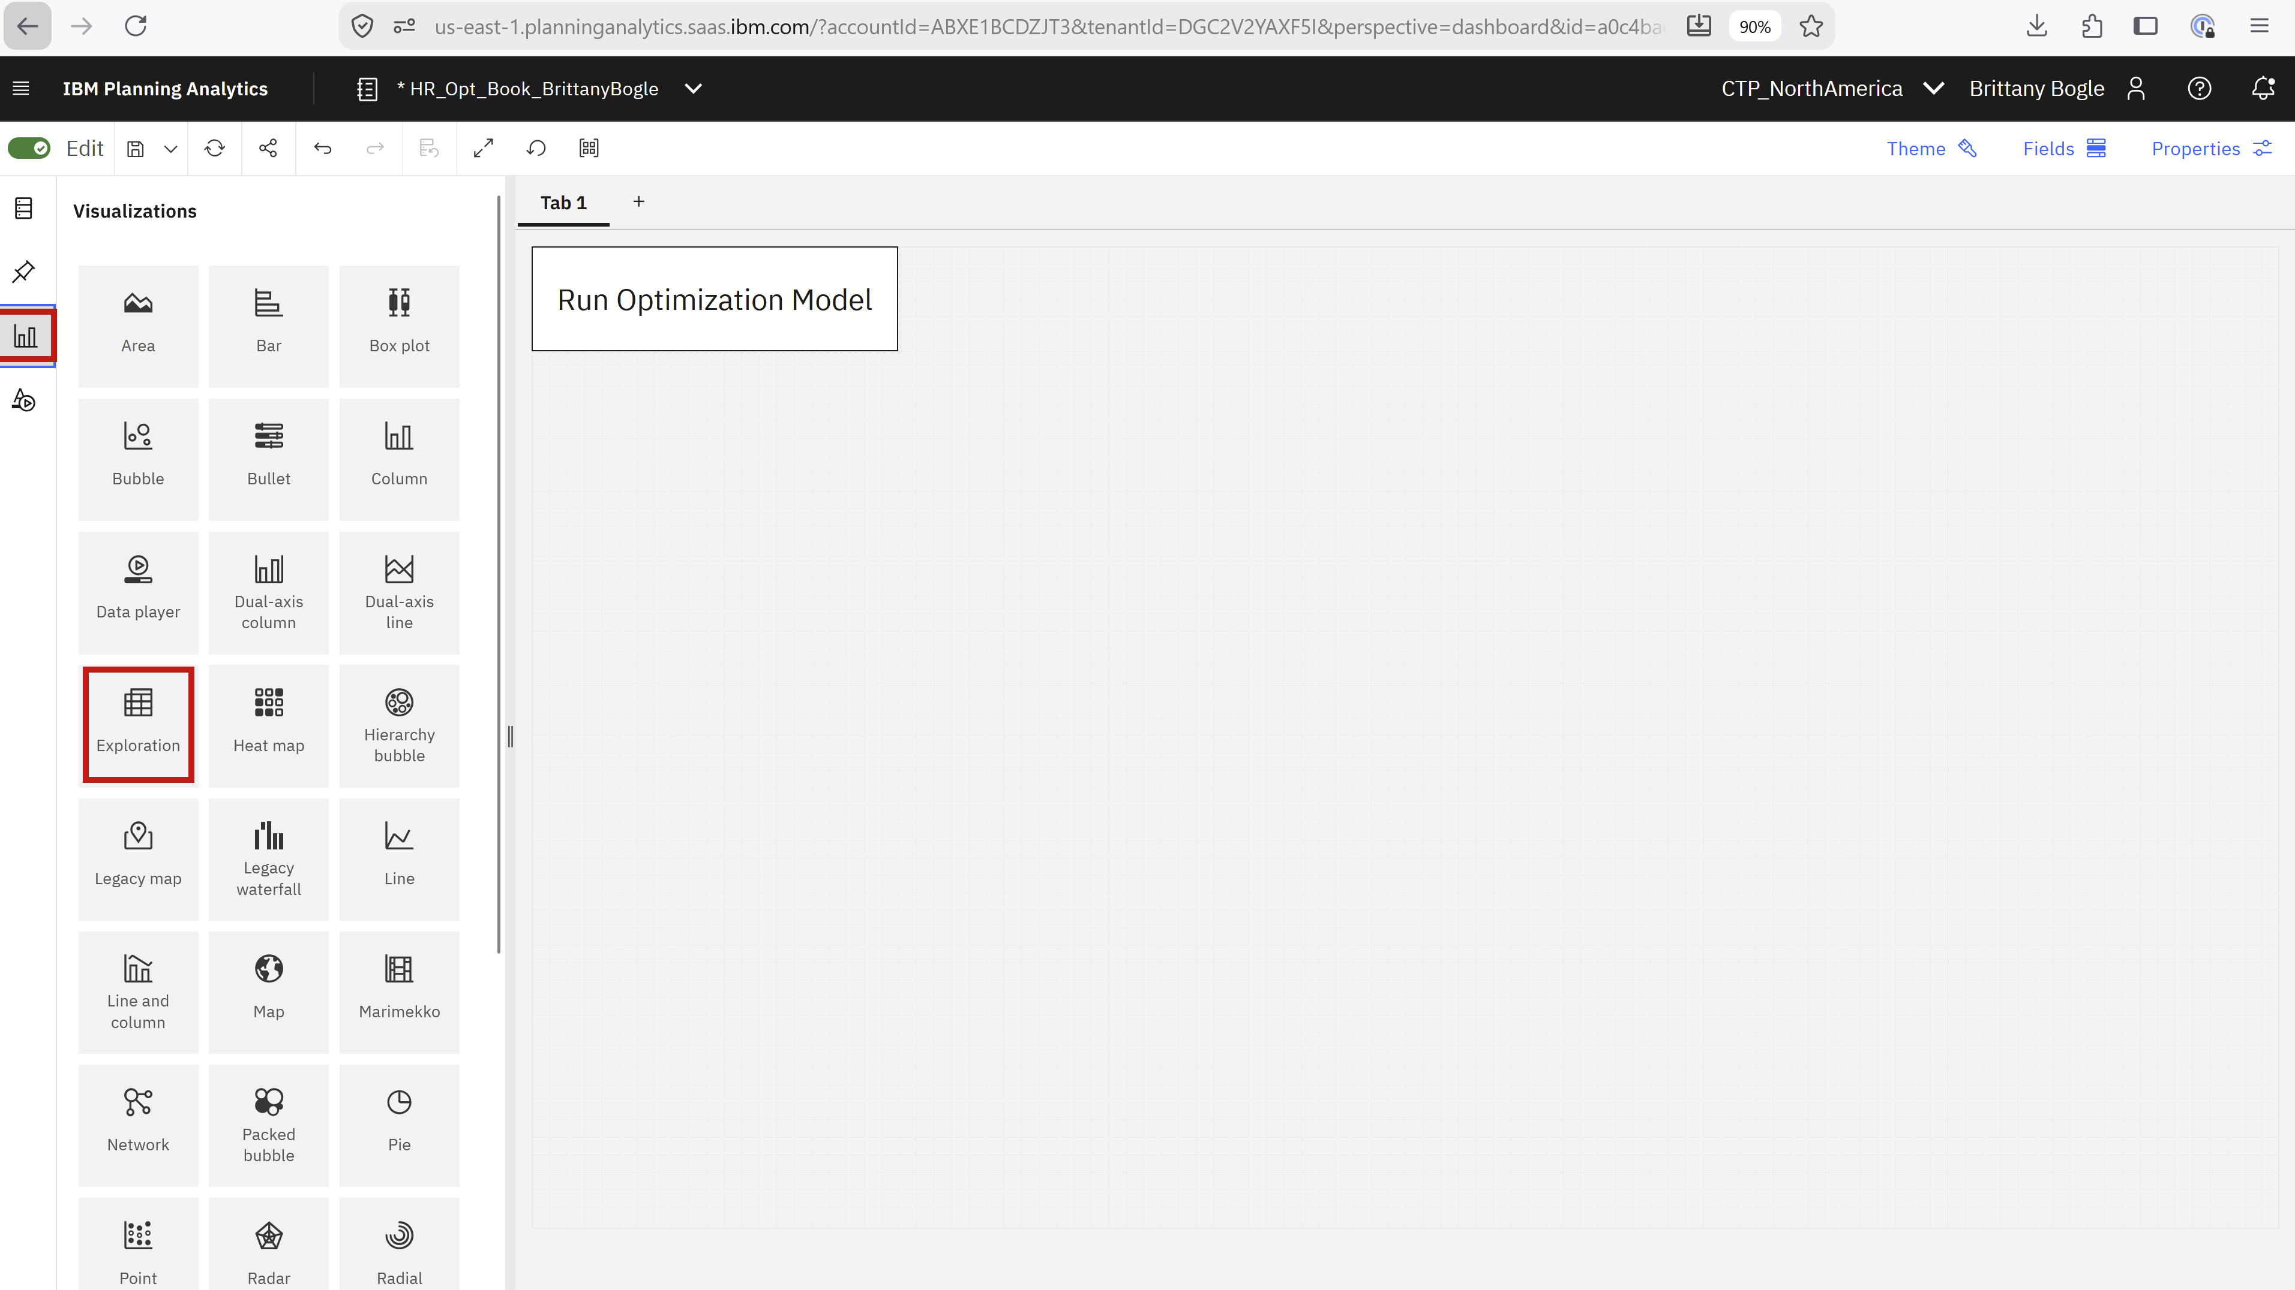

- Click the Database logo on the left panel, then expand HR_Optimization.
Then expand Cubes and drag Budget Control into the Explorations section of your book.
- Click the three dots next to the column section of the Explorations table. Then click Open set editor.
- Click the first member name (Total Budget Cap) and then Shift+Click Night Band Max FTE. Then Click the Remove button. Then click Apply.
- Click the three dots next to the rows section of the Explorations table. Then click Open set editor.
- Remove all Members except your FirstNameLastName member.

- Switch the row and columns by dragging the Selection dropdowns to the opposite location.

- Hit Save icon.

- Optionally, you can create other Exploration views of the optimized schedule results by repeating the above steps for Headcount Optimizer, Merit Allocation, and Schedule Assignment cubes.

Run the model from the Planning Analytics Book.
- Toggle Edit to OFF
- Click Run Optimization Model
- View the results in the Exploration view in the book after the job completes!

